Q1. (a) The diagram shows the voltage-current graphs for three different electrical components.
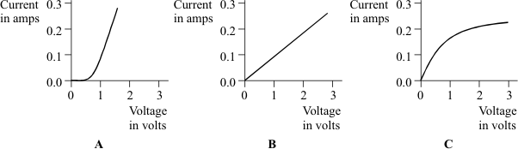

Which one of the components A, B or C could be a 3 volt filament lamp? Explain the reason for your choice.
.....................................................................................................................................
.....................................................................................................................................
.....................................................................................................................................
.....................................................................................................................................
(3)

(b) Using the correct symbols draw a circuit diagram to show how a battery, ammeter and voltmeter can be used to find the resistance of the wire shown.
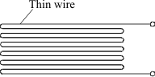
(3)

(c) When correctly connected to a 9 volt battery the wire has a current of 0.30 amperes flowing through it.
(i) Give the equation that links current, resistance and voltage.
..........................................................................................................................
(1)

(ii) Calculate the resistance of the wire. Show clearly how you work out your answer and give the unit.
..........................................................................................................................
..........................................................................................................................
Resistance = .........................................................
(3)

(iii) When the wire is heated, the current goes down to 0.26 amperes. State how the resistance of the wire has changed.
...........................................................................................................................
...........................................................................................................................
(1)
(Total 11 marks)

Q2. (a) Add the missing labels to the diagram.
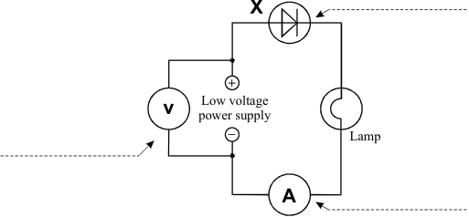
(3)

(b) Some students use the circuit shown above.
They want to find out how the current through component X changes as they change the voltage.
The graph shows their results.
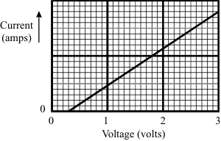
Describe, as fully as you can, what happens to the current through component X as the students increase the voltage.
....................................................................................................................................
....................................................................................................................................
....................................................................................................................................
....................................................................................................................................
....................................................................................................................................
(4)
(Total 7 marks)

Q3. The current through component X is measured when different voltages are applied across it.
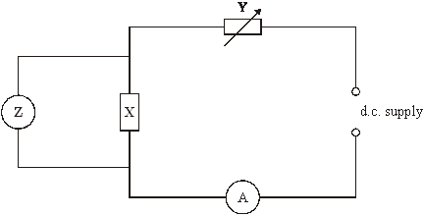

(a) Name the component labelled Y in the circuit.
.....................................................................................................................................
(1)

(b) What type of meter is Z?
.....................................................................................................................................
(1)

(c) The table shows the measurements obtained in this experiment.

Voltage in V | 0 | 0.2 | 0.4 | 0.6 | 0.8
Current in mA | 0 | 0 | 50 | 100 | 150

Draw a graph of the measurements.
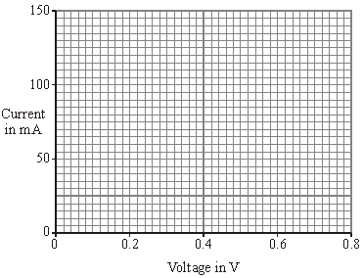
(2)

(d) Use the shape of the graph to name component X.
.....................................................................................................................................
(1)
(Total 5 marks)

Q4. A computer is set up to produce a graph of the current through an electric lamp during the first few milliseconds after it is switched on.
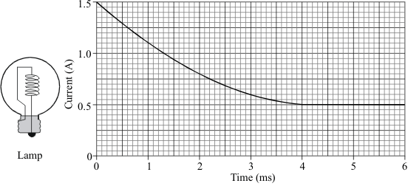

The lamp is modified then tested in the same way.
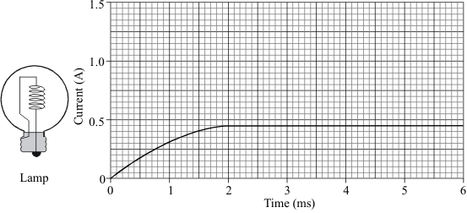

(a) Describe three differences in the way the lamp behaves after it has been modified.
1. ..........................................................................................................................
2. ..........................................................................................................................
3. ..........................................................................................................................
(3)

(b) The current through the modified lamp depends on the total resistance of the filament and component X.
The smaller this total resistance is, the greater the current.
The following graphs show how the resistance of the lamp filament and component X change as the lamp heats up to its operating temperature.
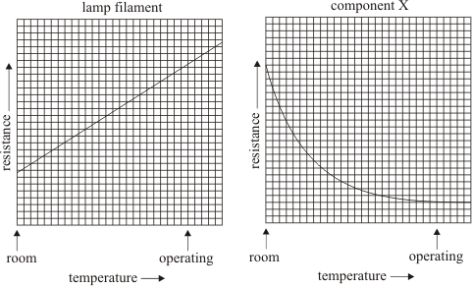

Use the information shown on the graphs to explain the behaviour of the modified lamp.
.....................................................................................................................................
.....................................................................................................................................
.....................................................................................................................................
.....................................................................................................................................
.....................................................................................................................................
.....................................................................................................................................
(4)
(Total 7 marks)

Q5. When a mains lamp is switched on it takes 0.5 seconds for the filament to reach its normal operating temperature. The way in which the current changes during the first second after switching on is shown in the sketch graph below. Mains voltage is 240 V.
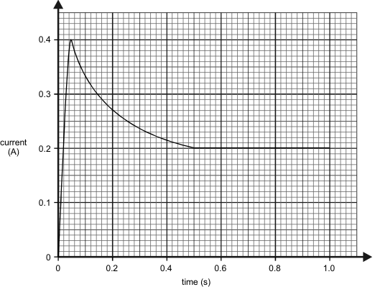

(a) Calculate the resistance of the filament whilst the lamp is drawing the maximum current.
....................................................................................................................................
....................................................................................................................................
....................................................................................................................................
(3)

(b) Describe how the resistance of the lamp changes after the current has reached its maximum value.
....................................................................................................................................
....................................................................................................................................
(2)

(c) Calculate the maximum power taken by the lamp.
....................................................................................................................................
....................................................................................................................................
....................................................................................................................................
(2)

(d) Calculate the power of the lamp in normal use.
....................................................................................................................................
....................................................................................................................................
....................................................................................................................................
(2)

(e) Calculate the energy used by the lamp in six hours of normal use.
....................................................................................................................................
....................................................................................................................................
....................................................................................................................................
(3)
(Total 12 marks)

Q6. A student investigates how the current flowing through a filament lamp changes with the voltage across it.
She is given a filament lamp and connecting wires.
She decides to use a 15V power supply, a variable resistor, an ammeter, a voltmeter and a switch.

(a) Complete the circuit diagram to show how she should set up the circuit.

(4)

(b) The student obtains the following results.
VOLTAGE (V) | 0.0 | 3.0 | 5.0 | 7.0 | 9.0 | 11.0
CURRENT (A) | 0.0 | 1.0 | 1.4 | 1.7 | 1.9 | 2.1

(i) Plot a graph of current against voltage.
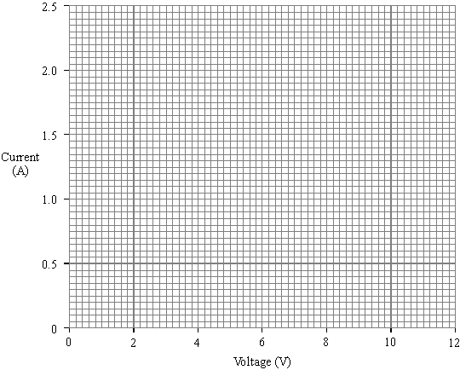
(3)

(ii) Use your graph to find the current when the voltage is 10V.
Current .................... A
(1)

(iii) Use your answer to (ii) to calculate the resistance of the lamp when the voltage is 10V.
...........................................................................................................................
...........................................................................................................................
...........................................................................................................................
Resistance .................... Ω
(2)

(c) (i) What happens to the resistance of the lamp as the current through it increases?
...........................................................................................................................

(ii) Explain your answer.
...........................................................................................................................
...........................................................................................................................
...........................................................................................................................
(2)
(Total 12 marks)

Q7. The diagram shows an electronic circuit.
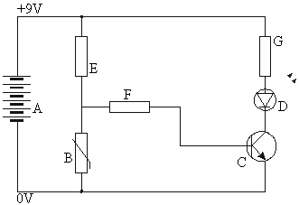

(a) Write down the names of the components in the list below.
A = .................................................................................................
B = .................................................................................................
C = .................................................................................................
D = .................................................................................................
E, F and G = .................................................................................................
(5)

(b) The graph shows how the resistance of component B depends on its temperature.
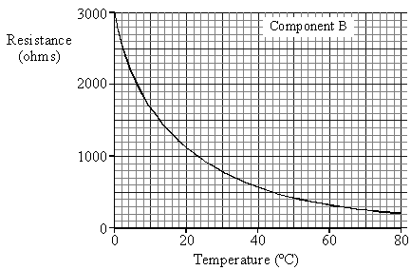
Describe, in as much detail as you can, how the resistance of component B changes as its temperature rises from 0ºC to 80ºC.
.....................................................................................................................................
.....................................................................................................................................
.....................................................................................................................................
.....................................................................................................................................
.....................................................................................................................................
(4)

(c) At what temperature does component B have a resistance of 1000 ohms?
Answer ......................................... °C .
(2)
(Total 11 marks)

Q8. Some students want to find out how the current through component X changes with the voltage they use.
The diagram shows their circuit. The graph shows their results.
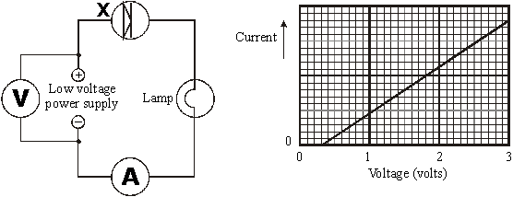

(a) Describe, as fully as you can, what happens to the current through component X as the students increase the voltage.
....................................................................................................................................
....................................................................................................................................
....................................................................................................................................
(4)

(b) The students want to find out whether component X allows the same current to flow through it in the opposite direction.
(i) How should they change the circuit to test this?
...........................................................................................................................
(1)

(ii) The graph shows the students’ extra results.
What do the extra results tell you?
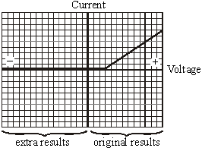
.........................................................................................................................
.........................................................................................................................
.........................................................................................................................
(1)
(Total 6 marks)

