Q1. The diagrams below represent three atoms, A, B and C.
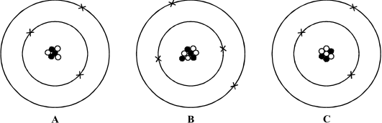

(a) Two of these atoms are from the same element.
(i) Which of A, B and C is an atom of a different element? ................................
(ii) Give one reason for your answer.
...........................................................................................................................
...........................................................................................................................
...........................................................................................................................
(2)

(b) Two of these atoms are isotopes of the same element.
(i) Which two are isotopes of the same element? .................... and ....................
(ii) Explain your answer.
...........................................................................................................................
...........................................................................................................................
...........................................................................................................................
(3)

(c) Which of the particles , and X, shown in the diagrams:
(i) has a positive charge; ....................
(ii) has no charge; ....................
(iii) has the smallest mass? ....................
(3)

(d) Using the same symbols as those in the atom diagrams, draw an alpha particle.

(1)
(Total 9 marks)

Q2. The diagram shows a film badge worn by people who work with radioactive materials. The badge has been opened. The badge is used to measure the amount of radiation to which the workers have been exposed.
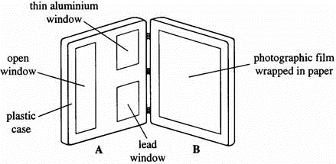

(a) The detector is a piece of photographic film wrapped in paper inside part B of the badge.
Part A has “windows” as shown.
Complete the sentences below.

When the badge is closed
(i) ........................ radiation and ........................ radiation can pass through the open
window and affect the film.
(1)

(ii) Most of the ........................ radiation will pass through the lead window and
affect the film.
(1)

(b) Other detectors of radiation use a gas which is ionised by the radiation.
(i) Explain what is meant by ionised.
...........................................................................................................................
...........................................................................................................................
(1)

(ii) Write down one use of ionising radiation.
...........................................................................................................................
(1)

(c) Uranium-238 has a very long half-life. It decays via a series of short-lived radioisotopes to produce the stable isotope lead-204.
Explain, in detail, what is meant by:
(i) half-life,
...........................................................................................................................
...........................................................................................................................
(1)
(ii) radioisotopes.
...........................................................................................................................
...........................................................................................................................
...........................................................................................................................
...........................................................................................................................
(2)

(d) The relative proportions of uranium-238 and lead-204 in a sample of igneous rock can be used to date the rock.
A rock sample contains three times as many lead atoms as uranium atoms.
(i) What fraction of the original uranium is left in the rock?
(Assume that there was no lead in the original rock.)
...........................................................................................................................
...........................................................................................................................
(1)

(ii) The half-life of uranium-238 is 4500 million years.
Calculate the age of the rock.
...........................................................................................................................
...........................................................................................................................
...........................................................................................................................
Age .................... million years
(2)
(Total 10 marks)

Q3.Radioactive sources emit alpha, beta and gamma radiation.
(a) The diagram shows a radioactive source. In front of the source is a screen.
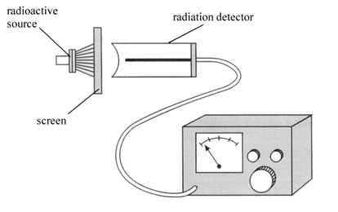
In each of the following cases state the type of radiation which is stopped by the screen.
Each type of radiation is to be used once only.
(i) What type of radiation is stopped when the screen is made of thick paper?
...............................................................................................................

(ii) What other type of radiation is stopped when the screen is made of thick aluminium?
...............................................................................................................

(iii) What other type of radiation is mainly stopped when the screen is made of thick lead?
...............................................................................................................
(3)

(b) Very penetrating radiation is produced in nuclear reactors. Nuclear reactors are shielded with lead or concrete.
The lead/concrete shielding does not stop all the radiation getting out.
Explain why shielding is important, even if it is only partially effective.
........................................................................................................................
........................................................................................................................
........................................................................................................................
........................................................................................................................
(2)
(Total 5 marks)

Q4. The diagram below shows the paths of two alpha particles A and B into and out of a thin piece of metal foil.
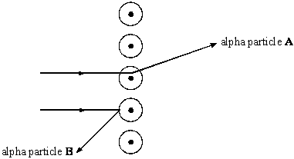

(a) The paths of the alpha particles depend on the forces on them in the metal.
Describe the model of the atom which is used to explain the paths of alpha particles aimed at thin sheets of metal foil.
....................................................................................................................................
....................................................................................................................................
....................................................................................................................................
....................................................................................................................................
(3)

(b) Scientists used to believe that atoms were made up of negative charges embedded in a positive ‘dough’. This is called the ‘plum pudding’ model of the atom.
The diagram below shows a model of such an atom.
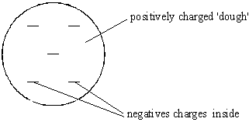

(i) Explain how the ‘plum pudding’ model of the atom can explain why alpha particle A is deflected through a very small angle.
............................................................................................................................
............................................................................................................................
............................................................................................................................
............................................................................................................................
............................................................................................................................
(2)

(ii) Explain why the ‘plum pudding’ model of the atom can not explain the large deflection of alpha particle B.
............................................................................................................................
............................................................................................................................
............................................................................................................................
............................................................................................................................
............................................................................................................................
............................................................................................................................
(3)

(c) We now believe that atoms are made up of three types of particles called protons, neutrons and electrons.
Complete the table below to show the relative mass and charge of a neutron and an electron. The relative mass and charge of a proton have already been done for you.
PARTICLE | RELATIVE MASS | RELATIVE CHARGE
proton | 1 | +1
neutron
electron

(2)

(d) The diagrams below show the nuclei of four different atoms A, B, C and D.
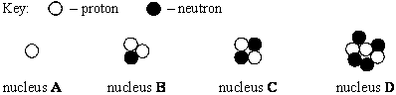

(i) State the mass number of C. ..................................................

(ii) Which two are isotopes of the same element? .................... and .....................
Explain your answer.
............................................................................................................................
............................................................................................................................
............................................................................................................................
............................................................................................................................
(4)
(Total 14 marks)

Q5. (a) A radioactive isotope has a half-life of 10 minutes.
At the start of an experiment, the activity of a sample of this isotope was 800 counts per second after allowing for background radiation.
Calculate how long it would be before the activity fell from 800 counts per second to 200 counts per second.
....................................................................................................................................
....................................................................................................................................
Time .......................... min.
(2)

(b) A physicist investigates a solid radioactive material. It emits alpha particles, beta particles and gamma rays.
The physicist does not touch the material.
Explain why the alpha particles are less dangerous than the beta particles and gamma rays.
....................................................................................................................................
....................................................................................................................................
....................................................................................................................................
....................................................................................................................................
(2)
(Total 4 marks)

##
(a) Atoms are made up of three types of particle called protons, neutrons and electrons.
Complete the table below to show the relative mass and charge of a neutron and an electron. The relative mass and charge of a proton has already been done for you.
PARTICLE | RELATIVE MASS | RELATIVE CHARGE
proton | 1 | +1
neutron
electron

(2)

(b) The diagram below shows the paths of two alpha particles A and B, into and out of a thin piece of metal foil.
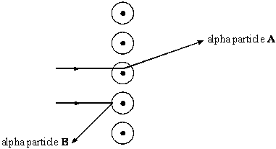
The paths of the alpha particles depend on the forces on them in the metal.
Describe the model of the atom which is used to explain the paths of alpha particles aimed at thin sheets of metal foil.
....................................................................................................................................
....................................................................................................................................
....................................................................................................................................
(3)
(Total 5 marks)

Q7.The diagram shows the electromagnetic spectrum.

Gamma rays | X-rays | Ultra violet | Visible light | Infra red | Microwaves | Radio

(a) Name the type of electromagnetic radiation which is used:
(i) to prevent fresh food going bad quickly. ...................................
(ii) to heat passengers’ meals in an aeroplane. ...................................
(2)

(b) (i) State one use of X-rays.
...............................................................................................................
...............................................................................................................
(1)

(ii) State one use of ultra violet radiation.
...............................................................................................................
...............................................................................................................
(1)

(c) Longer wavelength radio waves are used for communications over very long distances
without using satellites. Explain why this is possible.
........................................................................................................................
........................................................................................................................
(3)
(Total 7 marks)

Q8. (a) Tritium () is an isotope of hydrogen. Tritium has a proton number of 1 and a mass number of 3.
(i) The diagram below shows a simple model of a tritium atom. Complete the diagram by adding the names of the particles indicated by the labels.
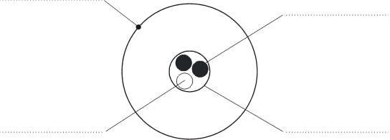
(4)

(ii) Explain how the nucleus of an ordinary hydrogen atom is different from the nucleus of a tritium atom. Ordinary hydrogen atoms () have a mass number of 1.
.........................................................................................................................
.........................................................................................................................
.........................................................................................................................
(2)

(iii) Tritium is a radioactive substance which emits beta (β) radiation.
Why do the atoms of some substances give out radiation?
.........................................................................................................................
.........................................................................................................................
(2)

(b) Tritium is one of the elements found in the waste material of the nuclear power industry. The diagram below shows a worker behind a protective screen. The container holds a mixture of different waste materials which emit alpha (α), beta (β) and gamma (γ) radiation.
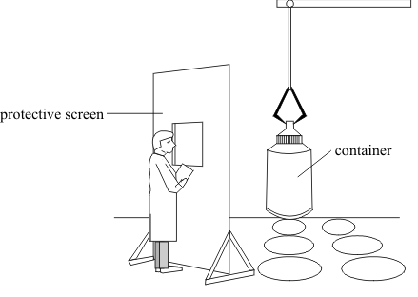

Suggest a suitable material for the protective screen. The material should prevent radiation from the container reaching the worker. Explain your answer.
...................................................................................................................................
...................................................................................................................................
...................................................................................................................................
(2)
(Total 10 marks)

Q9.(a) A beta particle is a high-energy electron.
(i) Which part of an atom emits a beta particle?
...............................................................................................................
(1)

(ii) How does the composition of an atom change when it emits a beta particle?
...............................................................................................................
(1)

(b) The diagram shows a badge used to monitor radiation. It measures the amount of radiation a worker has been exposed to in one month.
(i) What is used inside the badge to detect radiation?
...............................................................................................................
(1)

(ii) What would indicate that the worker has been exposed to a high level of radiation as opposed to a low level of radiation?
...............................................................................................................
...............................................................................................................
(1)

(iii) Why is it important to monitor the amount of radiation the worker has been exposed to?
...............................................................................................................
...............................................................................................................
(1)
(Total 5 marks)

Q10.The diagram shows the apparatus used by a teacher to measure the half-life of a radioactive source.
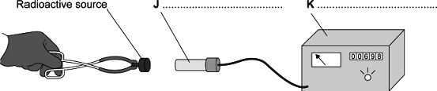
(a) Use words from the box to label the items J and K on the diagram.

 | control rod | Geiger–Müller tube | ratemeter | voltmeter

(2)

(b) Before using a radioactive source, a teacher asked her students to suggest procedures that would reduce the risk of her exposure to radiation. The students made the following suggestions.
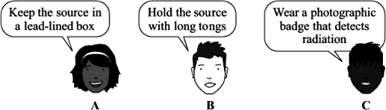

Which suggestion A, B or C, would reduce the health risk to the teacher while she is using the radioactive source?
............................................................
(1)

(c) (i) Before the source is put in place, the teacher takes three readings of the background count rate, in counts per minute, at one-minute intervals.
The readings are given in the table.

 | Count rate reading 1 | 25
 | Count rate reading 2 | 22
 | Count rate reading 3 | 43

Calculate the average background count rate.
...............................................................................................................
...............................................................................................................
Average background count rate = .................... counts per minute
(1)

(ii) At one point during the experiment, the count rate is 54 counts per minute.
Calculate how much of this reading is due to the radioactive source.
...............................................................................................................
................................................................................. counts per minute
(1)

(d) The count rate recorded by the teacher varied a lot. This is because radioactive decay is a random process.
Suggest one way that the teacher could obtain a more accurate value for the average background count rate.
........................................................................................................................
........................................................................................................................
(1)

(e) A group of students recorded readings at five-minute intervals.
They corrected their data for background count rate and put it in a table, as shown below.

 | Reading | Time in minutes | Corrected count rate  in counts per minute
 | A | 0 | 90
 | B | 5 | 52
 | C | 10 | 33
 | D | 15 | 28
 | E | 20 | 12

(i) Use the grid below to plot a graph of corrected count rate against time.
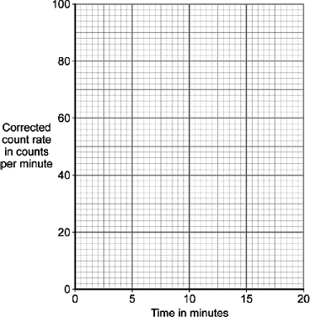
(2)

(ii) Use your graph to calculate the half-life of the radioactive source.
...............................................................................................................
...............................................................................................................
...............................................................................................................
...............................................................................................................
(2)

(f) Carbon-14 is a radioactive isotope of carbon, with a half-life of 5600 years, and is used for dating historical objects. 0.2g of carbon-14 is found in a sample today. How many grams of the isotope would have been present 16,800 years ago?
........................................................................................................................
........................................................................................................................
........................................................................................................................
........................................................................................................................
(3)
(Total 13 marks)

Q11.(a) Table 1 gives some properties of alpha, beta and gamma radiation.
 | Table 1
 | Radiation | Range in air | Effect of a magnetic field
 | Alpha particle | ................................ | deflected a small amount
 | Beta particle | about 1m | deflected a lot
 | Gamma ray | unlimited | .........................................

(i) Which one of the following describes an alpha particle?
Tick () one box.
It is the same as the nucleus of a helium atom.
It is an electron.
It is a negative ion.

(1)

(ii) Complete Table 1 by adding the missing information.
(2)

(b) Table 2 gives information about four radioactive isotopes.
 | Table 2
 | Isotope | Type of radiation  emitted | Half-life
 | iridium-192 | gamma ray | 74 days
 | polonium-210 | alpha particle | 138 days
 | polonium-213 | alpha particle | less than 1 second
 | technetium-99 | gamma ray | 6 hours

Two isotopes of polonium are given in the table. In terms of particles in the nucleus:
(i) how are these two isotopes the same
...............................................................................................................
(1)

(ii) how are these two isotopes different?
...............................................................................................................
(1)

(c) To monitor the blood flow through a patientߣs heart, a doctor injects the patient with a very small dose of technetium-99. The gamma radiation detected outside of the patient’s body allows the doctor to see if the heart is working correctly.
(i) Explain why technetium-99 is more suitable for this use than polonium-210.
...............................................................................................................
...............................................................................................................
...............................................................................................................
...............................................................................................................
(2)

(ii) Explain why technetium-99 is more suitable for this use than iridium-192.
...............................................................................................................
...............................................................................................................
...............................................................................................................
...............................................................................................................
(2)

(d) Technetium-99 (Tc) is produced by the beta decay (β) of an isotope of molybdenum (Mo).
The decay can be represented by the equation below.
Complete the equation by writing the correct number in each of the two boxes.

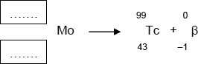
(2)
(Total 11 marks)

Q12.(a) The diagram shows part of the hydraulic brake system for a car.
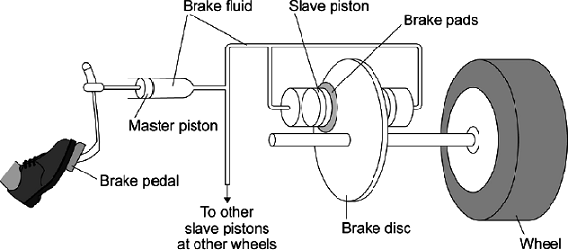
What property of a liquid is essential for a hydraulic brake system to work?
........................................................................................................................
(1)

(b) Describe how a force exerted on the brake pedal leads to a force acting on each of the brake discs.
........................................................................................................................
........................................................................................................................
........................................................................................................................
........................................................................................................................
........................................................................................................................
........................................................................................................................
........................................................................................................................
........................................................................................................................
(5)

(c) Applying the brakes of a car leads to an increase in the temperature of the brakes.
Explain why.
........................................................................................................................
........................................................................................................................
........................................................................................................................
........................................................................................................................
........................................................................................................................
........................................................................................................................
........................................................................................................................
........................................................................................................................
........................................................................................................................
(4)
(Total 10 marks)

