Q1. The picture shows an advert for an electric mobility scooter.
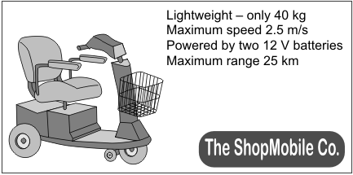
(a) The batteries are joined in series.

(i) What is the potential difference provided by the batteries to the motor?
...........................................................................................................................
(1)

(ii) The batteries supply a direct current (d.c.).
What is a direct current (d.c.)?
...........................................................................................................................
...........................................................................................................................
(1)

(b) At 2.5 m/s on flat ground, the motor takes a current of 3.0 A from the batteries.
(i) Explain why a bigger current is taken from the batteries when the scooter is going uphill at 2.5 m/s.
...........................................................................................................................
...........................................................................................................................
...........................................................................................................................
...........................................................................................................................
(2)
(ii) What effect does travelling uphill have on the range of the scooter?
...........................................................................................................................
(1)

(c) The mass of the scooter driver is 80 kg.
Use the equation in the box to calculate the kinetic energy of the scooter and driver when they are travelling at maximum speed.

Q2. (a) The diagram shows a fan heater.
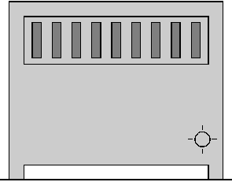

(i) A current of 11A flows when the fan heater is working normally.
Fuses of value 3A, 5A, 10A and 13A are available.
Which one should be used in the plug of the fan heater?
...................................
(1)

(ii) A fault caused a much higher than normal current to flow in the heater.
Describe what happened to the wire in the fuse.
............................................................................................................................
............................................................................................................................
............................................................................................................................
............................................................................................................................
(2)

(b)
You may find this equation useful when answering this part of the question

energy transferred (kWh) = power (kilowatt, kW) × time (hour, h)

(i) The power of the fan heater is 2.75 kW.
Calculate how many kilowatt hours of energy are transferred when the fan heater is used for 6 hours.
............................................................................................................................
............................................................................................................................
............................................................................................................................
Number of kilowatt hours ........................
(2)

(ii) How much will it cost to use the fan heater for 6 hours if one Unit of electricity costs 7p?
............................................................................................................................
............................................................................................................................
Cost ..................... p
(2)
(Total 7 marks)

Q3. The diagram shows a type of electric immersion heater in a hot water tank. These hot water tanks are normally found in airing cupboards.
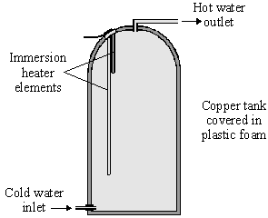
Information on the immersion heater states:
230 V
10 A

(a) (i) What is the equation which shows the relationship between power, current and voltage?
..........................................................................................................................
(1)

(ii) Calculate the power of the heater. Show clearly how you get to your answer and give the units.
..........................................................................................................................
Power = ......................................................
(2)

(b) (i) What rating of fuse should be in the immersion heater circuit?
..........................................................................................................................
(1)

(ii) There are three wires in the cable to the immersion heater. Two of the wires are connected to the immersion heater. The third wire is connected to the copper tank.
Explain the function of this third wire and the fuse in the circuit.
..........................................................................................................................
..........................................................................................................................
..........................................................................................................................
..........................................................................................................................
(3)

(c) (i) What is the equation which shows the relationship between resistance, current and voltage?
..........................................................................................................................
(1)

(ii) Calculate the resistance of the heater. Show clearly how you get to your answer and give the units.
..........................................................................................................................
Resistance = ....................................................
(2)
(Total 10 marks)

