Q1. A student designed the circuit below to measure temperature using a thermistor.
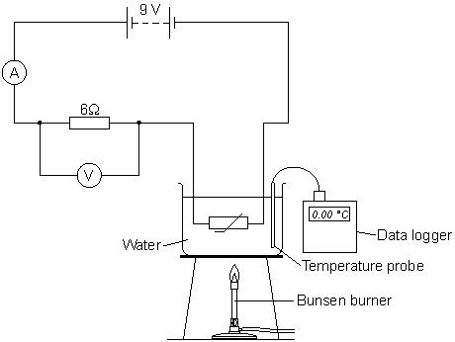
To calibrate the thermistor to measure temperature, the student placed the thermistor in a beaker of water at 0 °C and took the voltmeter reading. The student then heated the water slowly with a Bunsen burner. The student recorded the reading on the voltmeter every 10 °C.

(a) (i) Before calibrating the thermistor the student completed a risk assessment.
Write down one possible hazard that the student should have written in the risk assessment and what the student should do to reduce the risk of the hazard causing an injury.
...............................................................................................................
...............................................................................................................
...............................................................................................................
...............................................................................................................
...............................................................................................................
(2)

(ii) At 0 °C the reading on the ammeter is 0.5 A.
Calculate the reading on the voltmeter at 0 °C.
Write down the equation you use, and then show clearly how you work out your answer.
...............................................................................................................
...............................................................................................................
...............................................................................................................
Voltmeter reading = ..................................... V
(2)

(b) Most of the readings taken by the student are displayed in the graph.
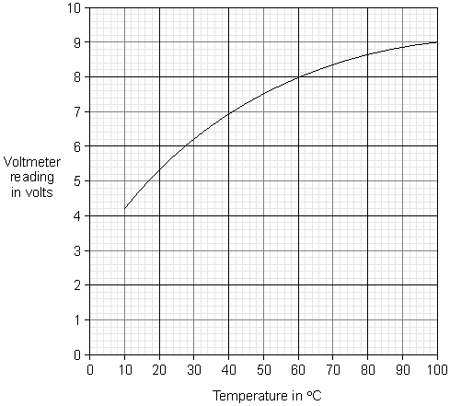

(i) Explain why the reading on the voltmeter changes when the temperature of the water increases.
...............................................................................................................
...............................................................................................................
...............................................................................................................
...............................................................................................................
...............................................................................................................
(3)

(ii) What is the temperature interval that can be measured with this circuit?
...............................................................................................................
...............................................................................................................
(1)

(iii) Once calibrated, between which temperatures would this circuit give the greatest resolution for temperature readings?
Tick () one box.

20 °C to 40 °C
40 °C to 60 °C
60 °C to 80 °C

Give a reason for your answer.
...............................................................................................................
...............................................................................................................
(2)

(c) Thermistors have many practical uses, including being used as a thermometer to measure temperature.
Give one other practical use for a thermistor.
........................................................................................................................
........................................................................................................................
(1)
(Total 11 marks)

Q2. The circuit shown has four identical ammeters.
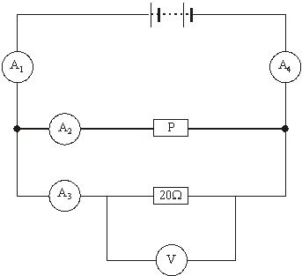

(a) The table gives the current through two of the ammeters.
(i) Complete the table to show the current through the other two ammeters.

Ammeter | Reading on ammeter in amps
A₁
A₂ | 0.2
A₃ | 0.3
A₄

(2)

(ii) Which one of the following statements is correct. Tick () the box next to your choice.
The resistance of P is more than 20 Ω.
The resistance of P is equal to 20 Ω.
The resistance of P is less than 20 Ω.
Give a reason for your choice.
...........................................................................................................................
...........................................................................................................................
...........................................................................................................................
(2)

(b) (i) Write down the equation that links current, potential difference and resistance.
...........................................................................................................................
(1)

(ii) Calculate the reading on the voltmeter. Show clearly how you work out your answer.
...........................................................................................................................
...........................................................................................................................
Voltmeter reading = ……………………………. volts.
(2)

(iii) State the potential difference of the power supply.
...........................................................................................................................
(1)

(c) A second circuit contains an unknown component labelled X.
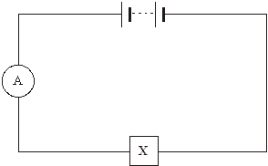
As component X is heated, the reading on the ammeter goes up.
What is component X?
.....................................................................................................................................
Give a reason for your answer.
.....................................................................................................................................
.....................................................................................................................................
(2)
(Total 10 marks)

Q3. (a) The circuit diagram drawn below includes a component labelled X.
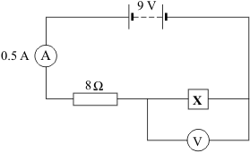
(i) Use the equation in the box to calculate the potential difference across the 8 ohm resistor.

potential difference = current × resistance

Show clearly how you work out your answer.
..........................................................................................................................
..........................................................................................................................
Potential difference = ................................................. volts
(2)

(ii) What is the potential difference across component X?
..........................................................................................................................
(1)

(b) The graph shows how the resistance of component X changes with temperature.
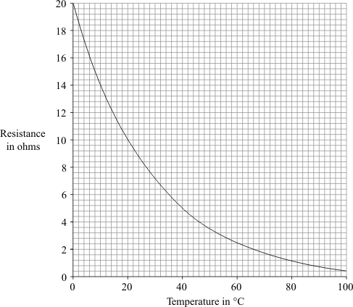
(i) What is component X?
.....................................................
(1)

(ii) Over which range of temperatures does the resistance of component X change the most?
Put a tick () next to your choice.
0 °C to 20 °C
20 °C to 40 °C
40 °C to 60 °C
60 °C to 80 °C
80 °C to 100 °C
(1)
(Total 5 marks)

Q4. A set of Christmas tree lights is made from twenty identical lamps connected in series.
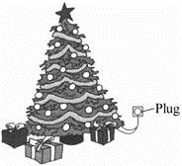

(a) Each lamp is designed to take a current of 0.25 A. The set plugs directly into the 230 V mains electricity supply.
(i) Write down the equation that links current, potential difference and resistance.
..........................................................................................................................
..........................................................................................................................
(1)

(ii) Calculate the resistance of one of the lamps. Show clearly how you work out your final answer and give the unit.
..........................................................................................................................
..........................................................................................................................
..........................................................................................................................
..........................................................................................................................
Resistance = ......................................................................
(4)

(iii) What is the total resistance of the set of lights?
..........................................................................................................................
..........................................................................................................................
Total resistance = ........................................................
(1)

(b) How does the resistance of a filament lamp change as the temperature of the filament changes?
.....................................................................................................................................
.....................................................................................................................................
.....................................................................................................................................
.....................................................................................................................................
(1)
(Total 7 marks)

Q5. The drawing shows the circuit used to investigate how the current through a 5 ohm (Ω) resistor changes as the potential difference (voltage) across the resistor changes.
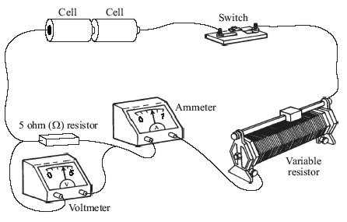

(a) Draw, in the space below, a circuit diagram of this circuit. Use the correct symbols for each part of the circuit.

(2)

(b) (i) Write down the equation that links current, potential difference and resistance.
...........................................................................................................................
(1)

(ii) Calculate the potential difference across the 5 ohm (Ω) resistor when the current through the resistor equals 0.4 A. Show clearly how you work out your final answer.
...........................................................................................................................
...........................................................................................................................
potential difference = .............................................. volts
(2)

(iii) Complete the graph to show how the current through the resistor changes as the potential difference across the resistor increases from 0 V to 3 V. Assume the resistor stays at a constant temperature.
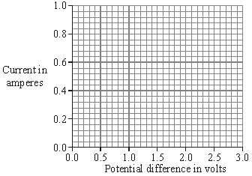
(2)

(c) The resistor is replaced by a 3 V filament lamp. The resistance of the lamp increases as the potential difference across it increases. Why?
.....................................................................................................................................
.....................................................................................................................................
(1)
(Total 8 marks)

Q6. The diagram below shows how one type of fuel gauge in a car works. A sliding contact makes contact with a resistance wire wound in a coil (rheostat). It is connected to a float via a pivot P. When the petrol level changes the circuit resistance changes. This causes the pointer in the fuel gauge to move and show how much petrol is in the petrol tank.
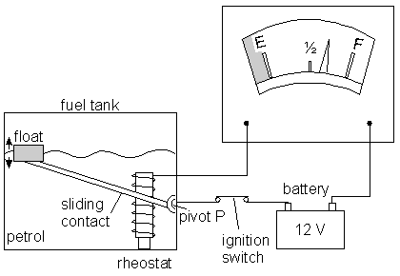
The circuit diagram is shown below.
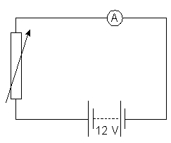

The petrol gauge is an ammeter. Explain why the reading on the ammeter falls as the petrol is used.
...............................................................................................................................................
...............................................................................................................................................
...............................................................................................................................................
...............................................................................................................................................
(Total 3 marks)

