Q1. The diagram shows how electricity gets from power stations to consumers.
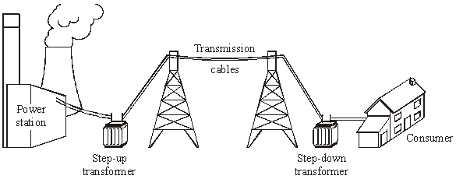
(a) Complete the following sentences by drawing a ring around the correct line in each box.

(i) The network of cables and transformers linking power stations to consumers is
called the national | grid  line  network

(1)
(ii)
A step-up transformer | decreases voltage  increases current  increases voltage

(1)
(iii)
Electricity is supplied to consumers’ homes at | 230 V  25 000 V  400 000 V

(1)
(iv)
Making the current in the cables smaller will | increase  make no difference to  reduce | the

energy lost in the cables.
(1)

(b) Transformers always waste some energy.

(i) What effect does the waste energy from a transformer have on the air around the transformer?
...........................................................................................................................
(1)

(ii) Which one of the following describes the efficiency of a transformer?
Draw a ring around your answer.
always 100 % less than 100 % more than 100%
(1)
(Total 6 marks)

Q2. The diagram shows the National Grid system.
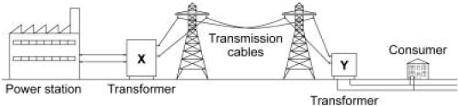
Transformers X and Y are an essential part of the National Grid system.
Explain why.
.................................................................................................................................
.................................................................................................................................
.................................................................................................................................
.................................................................................................................................
.................................................................................................................................
.................................................................................................................................
.................................................................................................................................
.................................................................................................................................
.................................................................................................................................
(Total 4 marks)

Q3. The outline diagram below shows part of the National Grid. At X the transformer increases the voltage to a very high value. At Y the voltage is reduced to 240 V for use by consumers.
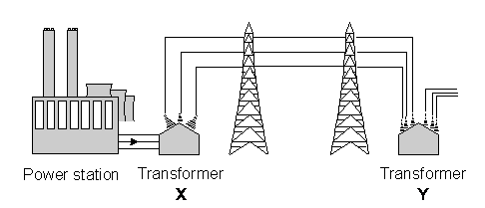

(i) At X a transformer increases the voltage. What happens to the current as the voltage is increased?
.....................................................................................................................................
(1)

(ii) Why is electrical energy transmitted at very high voltages?
.....................................................................................................................................
.....................................................................................................................................
(1)

(iii) The transformer at Y reduces the voltage before it is supplied to houses. Why is this done?
.....................................................................................................................................
.....................................................................................................................................
(1)
(Total 3 marks)

Q4. The diagram shows how electricity is distributed from power stations to consumers.
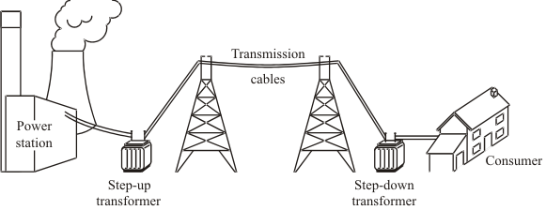
(a) (i) What name is given to the network of cables and transformers that links power stations to consumers?
...........................................................................................................................
(1)

(ii) What does a step-up transformer do?
...........................................................................................................................
(1)

(iii) Explain why step-up transformers are used in the electricity distribution system.
...........................................................................................................................
...........................................................................................................................
...........................................................................................................................
...........................................................................................................................
(2)

(b) Most of the world’s electricity is generated in power stations that burn fossil fuels.
State one environmental problem that burning fossil fuels produces.
.....................................................................................................................................
.....................................................................................................................................
(1)

(c) Electricity can be generated using energy from the wind. A company wants to build a new wind farm. Not everyone thinks that this is a good idea.
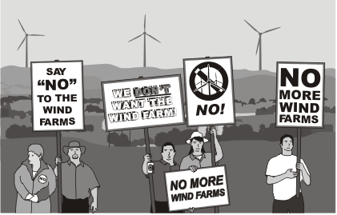

(i) What arguments could the company give to persuade people that a wind farm is a good idea?
...........................................................................................................................
...........................................................................................................................
...........................................................................................................................
...........................................................................................................................
(2)

(ii) What reasons may be given by the people who think that wind farms are not a good idea?
...........................................................................................................................
...........................................................................................................................
...........................................................................................................................
...........................................................................................................................
(2)
(Total 9 marks)

