Q1. The diagram shows the inside of a mains plug.
(a) Label the earth, live and neutral pins.
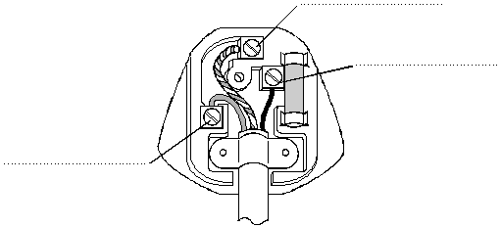
(3)

(b) (i) Explain how the earth wire and the fuse protect a person from an electric shock when there is a short circuit to the metal case of an appliance.
..........................................................................................................................
..........................................................................................................................
..........................................................................................................................
..........................................................................................................................
..........................................................................................................................
..........................................................................................................................
(4)

(ii) What is the most appropriate size fuse rating for a fuse in a television?
Circle the correct answer.
3 A 5 A 13 A
(1)
(Total 8 marks)

Q2. The diagram shows two oscilloscope traces, A and B.
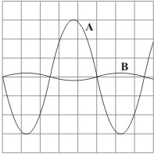
Trace A shows how the potential difference between the live and neutral terminals of an electricity supply changes with time.
(a) Describe how the potential of the live terminal varies with respect to the neutral terminal of the electricity supply.
....................................................................................................................................
....................................................................................................................................
(2)

(b) What does trace B show?
....................................................................................................................................
....................................................................................................................................
(1)

(c) Each horizontal division on the oscilloscope represents 0.005 s.
(i) What is the period of this electricity supply?
..........................................................................................................................
Period = .................................. seconds
(1)

(ii) Calculate the frequency of the supply.
..........................................................................................................................
Frequency = .................................. hertz
(1)
(Total 5 marks)

Q3. Carefully read the following extract from a safety leaflet. Then answer the questions.

An RCD adaptor is an automatic safety switch. It should be used when there is a particular risk of electric shock. For example, it is recommended that it is used with an electric lawnmower.
Inside one make of RCD is an electromagnet that holds the switch closed so that the RCD is switched on. An electronic circuit in the RCD monitors the difference between the current in the live wire and the current in the neutral wire.
If something goes wrong and this difference is greater than 30 milliamps then the RCD will trip (= switch off) within 40 milliseconds.

(a) Suggest two reasons why there is a particular risk of an electric shock when using an electric lawnmower.
1. ................................................................................................................................
.....................................................................................................................................
2. .................................................................................................................................
.....................................................................................................................................
(2)

(b) Why will there be a difference between the current in the live wire and the current in the neutral wire if something goes wrong?
.....................................................................................................................................
.....................................................................................................................................
(1)

(c) (i) Use the words charge, current and time to write an equation which shows the relationship between them.
..........................................................................................................................
(1)

(ii) Calculate how much charge flows when a current of 30 milliamps passes
for 40 milliseconds.
Clearly show how you get to your answer and give the unit.
..........................................................................................................................
..........................................................................................................................
Charge = .....................................................
(3)
(Total 7 marks)

Q4. The diagram shows someone accidentally touching the live wire inside a dismantled 230 volt mains electricity socket.
A current flows through the person giving him an electric shock.
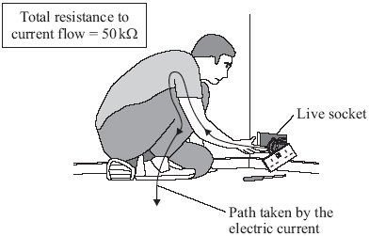

(a) (i) Use the equation in the box to calculate the current that will flow through the person.

potential difference = current × resistance

Show clearly how you work out your answer.
...........................................................................................................................
...........................................................................................................................
Current = ............................................................ A
(2)

(ii) Rubber is a good insulator.
Explain why it is a good idea for electricians to wear rubber soled boots when working.
...........................................................................................................................
...........................................................................................................................
...........................................................................................................................
...........................................................................................................................
(2)

(b) If the current flowing through a person is too high, the person cannot let go of the electrical source.
Different people were tested to see whether the ability to let go of an electrical source depended on the frequency of the current.
The results of the test are shown in the graph.
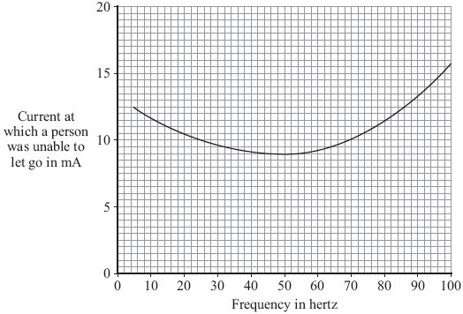

(i) What is the frequency of the mains electricity supply in the UK?
............................................................
(1)

(ii) From a safety point of view, is the frequency of the UK mains electricity supply suitable?
Give a reason for your answer.
...........................................................................................................................
...........................................................................................................................
(1)

(c) The diagram shows how the electric supply cable is connected to an electric kettle.
The earth wire is connected to the metal case of the kettle.
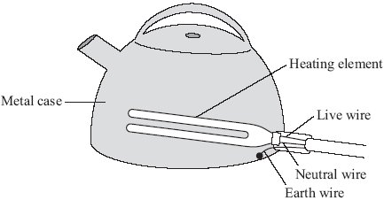
If a fault makes the metal case live, the earth wire and the fuse inside the plug protect anyone using the kettle from an electric shock.
Explain how.
.....................................................................................................................................
.....................................................................................................................................
.....................................................................................................................................
.....................................................................................................................................
(2)
(Total 8 marks)

Q5. (a) An adaptor can be used to connect up to four appliances in parallel to one 230 V mains socket. The adaptor is fitted with a 13 A fuse. The table gives a list of appliances and the current they draw from a mains socket.
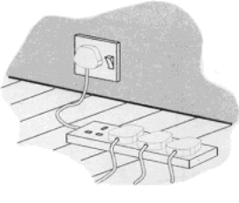

Appliance | Current
computer | 1 A
hairdryer | 4 A
heater | 8 A
iron | 6 A
television | 2 A

(i) What current will flow to the adaptor when the television, computer and hairdryer are plugged into the adaptor?
..........................................................................................................................
Current = .................................. A
(1)

(ii) Write down the equation which links current, electrical power and voltage.
..........................................................................................................................
(1)

(iii) Calculate the electrical power used when the television, computer and hairdryer are plugged into the adaptor. Show clearly how you work out your answer and give the unit.
..........................................................................................................................
..........................................................................................................................
..........................................................................................................................
Electrical power = ......................................
(2)

(iv) What would happen to the fuse if the heater is also plugged into the adaptor?
Give a reason for your answer.
..........................................................................................................................
..........................................................................................................................
(2)

(b) The diagram shows two of the appliances.
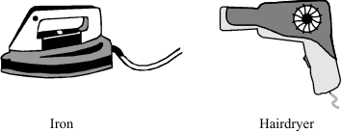

(i) For safety reasons, it is important that the iron has an earth wire connected to its outer metal case. Explain why.
..........................................................................................................................
..........................................................................................................................
..........................................................................................................................
..........................................................................................................................
(2)

(ii) The hairdryer does not have an earth wire. It is safe to use because it is double insulated. Explain what the term double insulated means.
..........................................................................................................................
..........................................................................................................................
..........................................................................................................................
..........................................................................................................................
(2)
(Total 10 marks)

Q6. In the UK mains electricity is a 230 volt a.c. supply.
(a) What is the frequency of the a.c. mains electricity in the UK?
........................................................................................................................
(1)

(b) (i) What is an electric current?
...............................................................................................................
(1)

(ii) Explain the difference between an a.c. (alternating current) electricity supply and a d.c. (direct current) electricity supply.
...............................................................................................................
...............................................................................................................
...............................................................................................................
...............................................................................................................
(2)

(c) A householder has a 10.8 kW electric shower installed in the bathroom.
(i) Calculate the current drawn from the mains electricity supply by the shower.
Write down the equation you use, and then show clearly how you work out your answer.
...............................................................................................................
...............................................................................................................
...............................................................................................................
...............................................................................................................
Current = .................................... A
(2)

(ii) The table gives the maximum current that can safely pass through electric cables of different cross-sectional area.

Cross-sectional  area  in mm ² | Maximum safe  current  in amps
1.0 | 11.5
2.5 | 20.0
4.0 | 27.0
6.0 | 34.0
10.0 | 46.0
16.0 | 62.0

The existing power sockets in the house are wired to the mains electricity supply using 2.5 mm² cable.
Use the data in the table to explain why the shower must not be connected to the mains electricity supply using 2.5 mm² cable.
...............................................................................................................
...............................................................................................................
...............................................................................................................
...............................................................................................................
(2)

(iii) The circuit connecting the shower to the mains electricity supply must include a residual current circuit breaker (RCCB) and not a fuse.
Give two advantages of using a RCCB to protect a circuit rather than a fuse.
1 ............................................................................................................
...............................................................................................................
2 ............................................................................................................
...............................................................................................................
(2)
(Total 10 marks)

Q7. (a) Describe the difference between an alternating current (a.c.) and a direct current (d.c.).
.....................................................................................................................................
.....................................................................................................................................
.....................................................................................................................................
.....................................................................................................................................
(2)

(b) The diagram shows the information plate on the bottom of an electric wallpaper steamer.
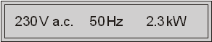

(i) Use the equation in the box to calculate the current used by the steamer.
power = current × potential difference

Show clearly how you work out your answer.
...........................................................................................................................
...........................................................................................................................
Current .............................. A
(2)

(ii) Which one of the following fuses should be used inside the plug of the steamer?
Draw a ring around your answer.
1 A 3 A 5 A 10 A 13 A
(1)
(Total 5 marks)

