Q1. (a) A radioactive source emits alpha (α), beta (β) and gamma (γ) radiation.
(i) Which two types of radiation will pass through a sheet of card?
...........................................................................................................................
(1)
(ii) Which two types of radiation would be deflected by an electric field?
...........................................................................................................................
(1)
(iii) Which type of radiation has the greatest range in air?
...........................................................................................................................
(1)

(b) A student suggests that the radioactive source should be stored in a freezer at – 20 °C. The student thinks that this would reduce the radiation emitted from the source.
Suggest why the student is wrong.
......................................................................................................................................
......................................................................................................................................
(1)

(c) Phosphorus-32 is a radioactive isotope that emits beta radiation.
(i) How is an atom of phosphorus-32 different from an atom of the stable isotope phosphorus-31?
...........................................................................................................................
...........................................................................................................................
(1)

(ii) The graph shows how the count rate of a sample of phosphorus-32 changes with time.
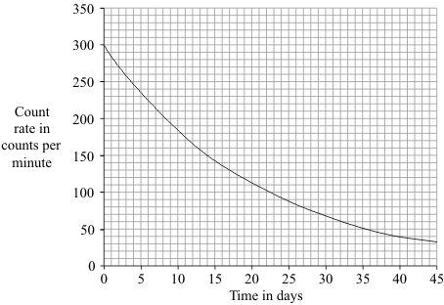
Use the graph to calculate the half-life of phosphorus-32.
Show clearly how you used the graph to obtain your answer.
...........................................................................................................................
...........................................................................................................................
Half-life = ....................................... days
(2)

(iii) Plants use phosphorus compounds to grow. Watering the root system of a plant with a solution containing a phosphorus-32 compound can help scientists to understand the growth process.
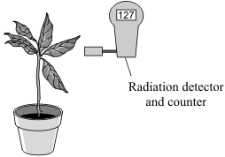
Explain why phosphorus-32 is suitable for use as a tracer in this situation.
...........................................................................................................................
...........................................................................................................................
...........................................................................................................................
...........................................................................................................................
(2)
(Total 9 marks)

Q2. (a) The table gives information about the radioactive isotope, radon-222.

mass number | 222
atomic number | 86
radiation emitted | alpha particle

(i) Complete the following sentence.
The mass number is the total number of ............................................................ and
.................................................. inside an atom.
(2)

(ii) Radon-222 is an isotope of radon.
How many protons are there in an atom of radon-222?
...................................
(1)

(iii) When an atom of radon-222 emits an alpha particle, the radon-222 changes into an atom of polonium-218.
An alpha particle consists of 2 protons and 2 neutrons.
How is the structure of the nucleus of a polonium-218 atom different from the structure of the nucleus of a radon-222 atom?
..........................................................................................................................
(1)

(b) The pie chart shows the average radiation dose that a person in the UK receives each year from natural background radiation.
The doses are measured in millisieverts (mSv).
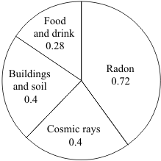
(i) Calculate the proportion of natural background radiation that comes from radon. Show clearly how you work out your answer.
..........................................................................................................................
..........................................................................................................................
Proportion of radon = .................................................
(2)

(ii) Not all background radiation is from natural sources.
Name one source of background radiation that is not natural.
..........................................................................................................................
(1)

(c) The bar chart shows the average yearly dose from natural background radiation in different European countries.
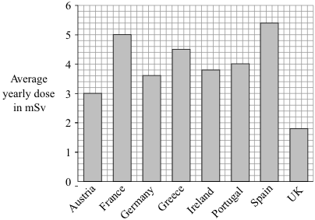
(i) How many times bigger is the average annual background dose in Germany compared to the UK?
..........................................................................................................................
(1)

(ii) The following table gives the effects of different radiation doses on the human body.

Radiation dose in mSv | Effects
10 000 | Immediate illness; death within a few weeks
1 000 | Radiation sickness; unlikely to cause death
50 | Lowest dose with evidence of causing cancer

A family goes to Germany for a two-week holiday. Should they be concerned about the higher level of background radiation in Germany?
Draw a ring around your answer.
Yes No
Explain your answer.
..........................................................................................................................
..........................................................................................................................
..........................................................................................................................
..........................................................................................................................
(2)
(Total 10 marks)

Q3. (a) Alpha particles (α), beta particles (β) and gamma rays (γ) are types of nuclear radiation.

(i) Which of the three types of radiation is the most strongly ionising?
...........................................................................................................................
(1)

(ii) What effect does nuclear radiation have on living cells?
...........................................................................................................................
(1)

(b) The diagrams show a G-M tube and counter used to measure the radiation emitted from a source. Both diagrams show the reading on the counter one minute after it was switched on.
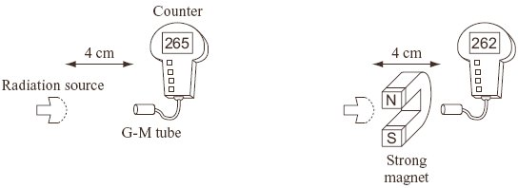
Explain why the counter readings show that the source is giving out only gamma radiation.
.....................................................................................................................................
.....................................................................................................................................
.....................................................................................................................................
.....................................................................................................................................
(2)

(c) The box gives information about the radioactive isotope technetium-99.
Type of radiation emitted: gamma
Half-life: 6 hours
Used as a medical tracer

What is meant by the term half-life?
.....................................................................................................................................
.....................................................................................................................................
(1)

(d) To study the blood flow in a patient’s lungs, a doctor injects a small quantity of a technetium-99 compound into the patient. The radiation emitted by the technetium-99 atoms is detected outside the patient’s body.
Explain why a doctor would not use a radioactive isotope with a very short half-life, such as 2 seconds, as a medical tracer.
.....................................................................................................................................
.....................................................................................................................................
.....................................................................................................................................
.....................................................................................................................................
(2)
(Total 7 marks)

Q4. The first commercial nuclear power station in the world was built at Calder Hall in Cumbria.
(a) The fuel used at the Calder Hall power station is uranium. Natural uranium consists mainly of two isotopes: uranium-235 and uranium-238. The nucleus of a uranium-235 atom is different to that of a uranium-238 atom.
(i) Where is the nucleus in an atom?
..........................................................................................................................
(1)

(ii) Name the two types of particle found in the nucleus.
........................................................... and ........................................................
(2)

(iii) How is the nucleus of a uranium-238 atom different to the nucleus of a uranium-235 atom?
..........................................................................................................................
..........................................................................................................................
..........................................................................................................................
(2)

(b) In the nuclear reactor fission of uranium atoms takes place in reactions such as the one shown below.
+ + + 3()
The nuclear reactions are carefully controlled in the power station so that a chain reaction takes place.

Explain, as fully as you can:
(i) how fission of uranium atoms takes place in a nuclear reactor;
..........................................................................................................................
..........................................................................................................................
..........................................................................................................................
..........................................................................................................................

(ii) how this leads to a chain reaction;
..........................................................................................................................
..........................................................................................................................
..........................................................................................................................
..........................................................................................................................

(iii) why it can be used to generate electricity.
..........................................................................................................................
..........................................................................................................................
(4)
(Total 9 marks)

##
(a) The table shows the half-life of some radioactive isotopes.
Radioactive isotope | Half-life
magnesium-27 | 10 minutes
sodium-24 | 15 hours
sulphur-35 | 87 days
cobalt-60 | 5 years

(i) What is meant by the term radioactive?
..........................................................................................................................
..........................................................................................................................
(1)

(ii) Which one of the isotopes in the table could form part of a compound to be used as a tracer in medicine? Explain the reason for your choice.
..........................................................................................................................
..........................................................................................................................
..........................................................................................................................
..........................................................................................................................
..........................................................................................................................
(3)

(iii) Draw a graph to show how the number of radioactive atoms present in the isotope cobalt-60 will change with time.
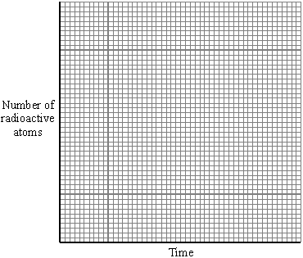
(3)

(b) Nuclear power stations provide about 17% of the world’s electricity. They add less than 1% to the total background levels of radiation. Some people are opposed to the use of nuclear fuels for the generation of electricity. Explain why.
.....................................................................................................................................
.....................................................................................................................................
.....................................................................................................................................
.....................................................................................................................................
.....................................................................................................................................
.....................................................................................................................................
(3)
(Total 10 marks)

Q6. (a) The graph shows how a sample of barium-143, a radioactive isotope with a short half-life, decays with time.
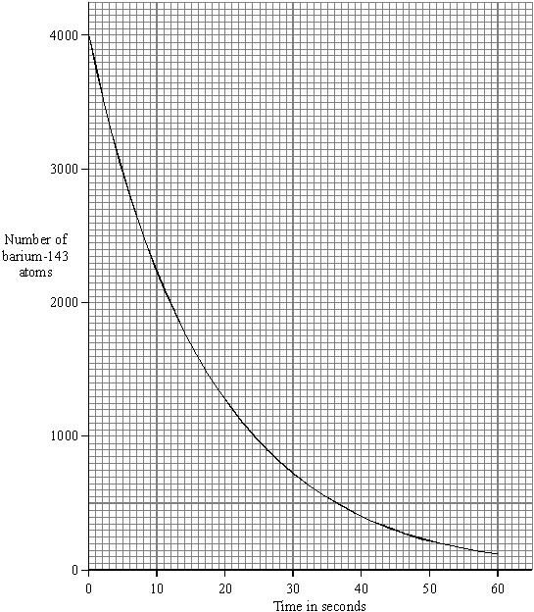

(i) What is meant by the term isotope?
..........................................................................................................................
..........................................................................................................................
(1)

(ii) What is meant by the term half-life?
..........................................................................................................................
..........................................................................................................................
(1)

(iii) Use the graph to find the half-life of barium-143.
Half-life = .............................. seconds
(1)

(b) Humans take in the radioactive isotope carbon-14 from their food. After their death, the proportion of carbon-14 in their bones can be used to tell how long it is since they died. Carbon-14 has a half-life of 5700 years.
(i) A bone in a living human contains 80 units of carbon-14. An identical bone taken from a skeleton found in an ancient burial ground contains 5 units of carbon-14. Calculate the age of the skeleton. Show clearly how you work out your answer.
..........................................................................................................................
..........................................................................................................................
..........................................................................................................................
Age of skeleton = .............................. years
(2)

(ii) Why is carbon-14 unsuitable for dating a skeleton believed to be about 150 years old?
........................................................................................................................
........................................................................................................................
(1)

(c) The increased industrial use of radioactive materials is leading to increased amounts of radioactive waste. Some people suggest that radioactive liquid waste can be mixed with water and then safely dumped at sea. Do you agree with this suggestion? Explain the reason for your answer.
..................................................................................................................................
..................................................................................................................................
..................................................................................................................................
..................................................................................................................................
..................................................................................................................................
..................................................................................................................................
..................................................................................................................................
..................................................................................................................................
(3)
(Total 9 marks)

Q7. (a) A radioactive isotope has a half-life of 10 minutes.
At the start of an experiment, the activity of a sample of this isotope was 800 counts per second after allowing for background radiation.
Calculate how long it would be before the activity fell from 800 counts per second to 200 counts per second.
....................................................................................................................................
....................................................................................................................................
Time .......................... min.
(2)

(b) A physicist investigates a solid radioactive material. It emits alpha particles, beta particles and gamma rays.
The physicist does not touch the material.
Explain why the alpha particles are less dangerous than the beta particles and gamma rays.
....................................................................................................................................
....................................................................................................................................
....................................................................................................................................
....................................................................................................................................
(2)
(Total 4 marks)

Q8. (a) A radiation detector and counter were used to detect and measure the radiation emitted from a weak source. The graph shows how the number of counts recorded in one minute changed with time.
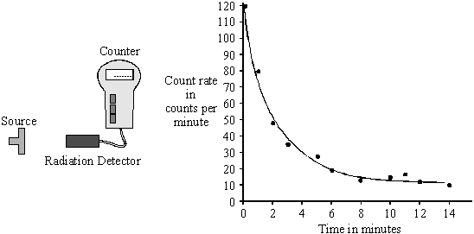

(i) Even though the readings from the counter were accurately recorded, not all the points fit the smooth curve. What does this tell us about the process of radioactive decay?
..........................................................................................................................
(1)

(ii) After ten minutes the number of counts recorded each minute is almost constant.
Explain why.
..........................................................................................................................
..........................................................................................................................
..........................................................................................................................
(2)

(b) The radioactive isotope sodium-24 injected into the bloodstream can be used to trace blood flow to the heart. Sodium-24 emits both beta particles and gamma rays.
(i) What is a beta particle?
..........................................................................................................................
(1)

(ii) What is a gamma ray?
..........................................................................................................................
..........................................................................................................................
(1)

(iii) The count rate from a solution containing sodium-24 decreases from 584 counts per minute to 73 counts per minute in 45 hours. Calculate the half-life of sodium-2.2. Show clearly how you work out your answer.
..........................................................................................................................
..........................................................................................................................
..........................................................................................................................
Half-life = ............................. hours
(3)

(iv) Give one advantage of using sodium-24 to trace blood flow compared to using an isotope with a half-life of:
[A] ten years; ...................................................................................................
..........................................................................................................................
(1)
[B] ten seconds. ...............................................................................................
..........................................................................................................................
(1)
(Total 10 marks)

Q9. In 1986, a nuclear reactor exploded in a power station at Chernobyl in the Ukraine.
(a) The table gives information about some of the radioactive substances released into the air by the explosion.

Radioactive  substance | Half-life | Type of radiation  emitted
Iodine-131 | 8 days | beta and gamma
Caesium-134 | 2 years | beta
Caesium-137 | 30 years | beta

(i) How is the structure of a caesium-134 atom different from the structure of a caesium-137 atom?
..........................................................................................................................
(1)

(ii) What is a beta particle and from which part of an atom is a beta particle emitted?
..........................................................................................................................
..........................................................................................................................
(1)

(iii) Once a radioactive substance is dissolved in rainwater, it can enter the food chain.
Following the Chernobyl explosion, some milk supplies were found to be radioactive.
If one litre of milk contaminated with iodine-131 gives a count rate of 400 counts/second, how long will it take for the count rate to fall to 25 counts/second?
Show clearly how you work out your answer.
..........................................................................................................................
..........................................................................................................................
..........................................................................................................................
Time taken = ................................................. days
(2)

(iv) After 20 years, the caesium-137 emitted into the atmosphere is a more serious problem than the iodine-131.
Explain why.
..........................................................................................................................
..........................................................................................................................
..........................................................................................................................
..........................................................................................................................
..........................................................................................................................
(2)

(b) The bar chart compares the incidence of thyroid cancer in Ukrainian children, aged 0–14 years, before and after the Chernobyl explosion.
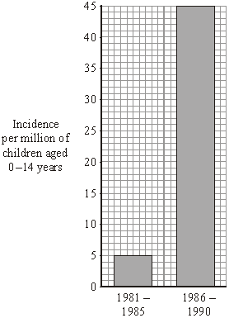
Of the children that developed thyroid cancer, 64% lived in the areas most contaminated by the radiation.

Considering this data, can you be certain that a child who developed thyroid cancer between 1986 and 1990 did so because of the Chernobyl explosion?
Explain the reason for your answer.
....................................................................................................................................
....................................................................................................................................
....................................................................................................................................
....................................................................................................................................
(2)

(c) In 1991, some scientists compared the health of two groups of people: a control group and a group that had been exposed to the radiation from Chernobyl.
What people would have been in the control group?
....................................................................................................................................
(1)

(d) Although there are some risks associated with nuclear power stations, it is likely that new ones will be built.
Give two reasons to justify the use of nuclear power.
1 .................................................................................................................................
....................................................................................................................................
2 .................................................................................................................................
....................................................................................................................................
(2)
(Total 11 marks)

Q10. Iodine-131 (¹³¹I) is a radioactive isotope used in medicine.
The graph shows how the count rate of a sample of iodine-131 changed over 24 days.
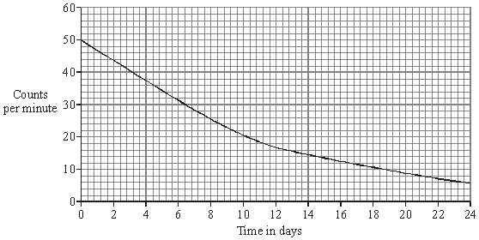

(i) Use the graph to calculate the half-life of iodine-131. To obtain full marks you should show clearly how you work out your answer.
.....................................................................................................................................
.....................................................................................................................................
.....................................................................................................................................
Half-life ................................ days
(2)

(ii) Iodine-131 is used to destroy cancer cells in the human thyroid gland.
Explain why the length of the half-life of iodine-131 is important in this use.
.....................................................................................................................................
.....................................................................................................................................
.....................................................................................................................................
.....................................................................................................................................
(2)
(Total 4 marks)

Q11. The radioactive isotope, carbon-14, decays by beta (β) particle emission.
(a) What is a beta (β) particle?
....................................................................................................................................
....................................................................................................................................
(1)

(b) Plants absorb carbon-14 from the atmosphere. The graph shows the decay curve for
1 g of carbon-l4 taken from a flax plant.
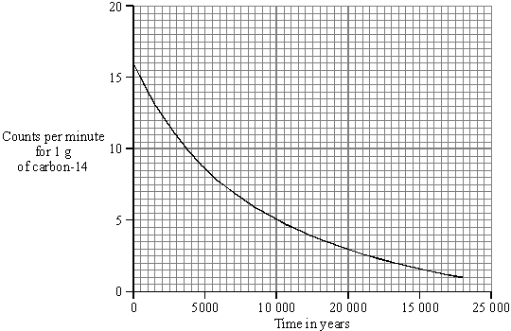
Use the graph to find the half-life of carbon-l4. You should show clearly on your graph how you obtain your answer.
Half-life = ................................. years.
(2)

(c) Linen is a cloth made from the flax plant. A recent exhibition included part of a linen shirt, believed to have belonged to St. Thomas à Becket, who died in 1162. Extracting carbon-14 from the cloth would allow the age of the shirt to be verified.
If 1 g of carbon-14 extracted from the cloth were to give 870 counts in 1 hour, would it be possible for the shirt to have once belonged to St. Thomas à Becket? You must show clearly the steps used and reason for your decision.
....................................................................................................................................
....................................................................................................................................
....................................................................................................................................
....................................................................................................................................
(3)
(Total 6 marks)

