Q1. Most elements have some isotopes which are radioactive.
(a) What is meant by the terms:
(i) isotopes
...........................................................................................................................
...........................................................................................................................
(1)

(ii) radioactive?
...........................................................................................................................
...........................................................................................................................
(1)

(b) The graph shows how the number of nuclei in a sample of the radioactive isotope plutonium-238 changes with time.
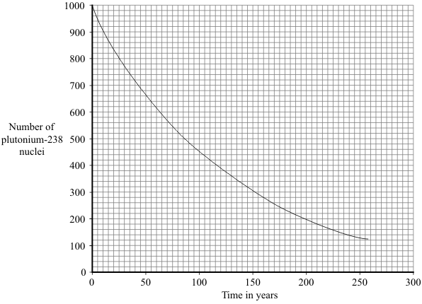

Use the graph to find the half-life of plutonium-238.
Show clearly on the graph how you obtain your answer.
Half-life = ............................ years
(2)

(c) The Cassini spacecraft launched in 1997 took seven years to reach Saturn.
The electricity to power the instruments on board the spacecraft is generated using the heat produced from the decay of plutonium-238.
(i) Plutonium-238 decays by emitting alpha particles.
What is an alpha particle?
...........................................................................................................................
(1)

(ii) During the 11 years that Cassini will orbit Saturn, the output from the generators will decrease.
Explain why.
...........................................................................................................................
...........................................................................................................................
...........................................................................................................................
...........................................................................................................................
(2)

(d) Plutonium-238 is highly dangerous. A tiny amount taken into the body is enough to kill a human.
(i) Plutonium-238 is unlikely to cause any harm if it is outside the body but is likely to kill if it is inside the body.
Explain why.
...........................................................................................................................
...........................................................................................................................
...........................................................................................................................
...........................................................................................................................
(2)

(ii) In 1964, a satellite powered by plutonium-238 was destroyed, causing the release of radioactive material into the atmosphere.
Suggest why some environmental groups protested about the launch of Cassini.
...........................................................................................................................
...........................................................................................................................
(1)
(Total 10 marks)

Q2. (a) The diagram shows what can happen when the nucleus of a uranium atom absorbs a neutron.
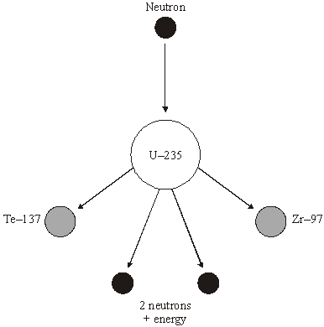
(i) What name is given to the process shown in the diagram?
...........................................................................................................................
(1)

(ii) Explain how this process could lead to a chain reaction.
You may wish to add further detail to the diagram to help your answer.
...........................................................................................................................
...........................................................................................................................
...........................................................................................................................
...........................................................................................................................
(2)

(iii) How does the mass number of an atom change when its nucleus absorbs a neutron?
...........................................................................................................................
(1)

(b) Uranium-235 is used as a fuel in some nuclear reactors.
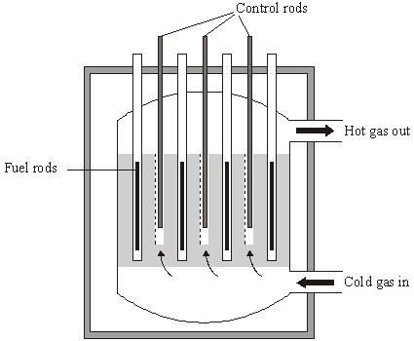
Source: adapted from ‘Physics Matters’, by Nick England. Published by
Hodder and Stoughton, 1989. Reproduced by permission of Hodder and Stoughton Ltd.
The reactor contains control rods used to absorb neutrons.
Suggest what happens when the control rods are lowered into the reactor.
.....................................................................................................................................
.....................................................................................................................................
.....................................................................................................................................
.....................................................................................................................................
(2)
(Total 6 marks)

Q3. The first commercial nuclear power station in the world was built at Calder Hall in Cumbria.
(a) The fuel used at the Calder Hall power station is uranium. Natural uranium consists mainly of two isotopes: uranium-235 and uranium-238. The nucleus of a uranium-235 atom is different to that of a uranium-238 atom.
(i) Where is the nucleus in an atom?
..........................................................................................................................
(1)

(ii) Name the two types of particle found in the nucleus.
........................................................... and ........................................................
(2)

(iii) How is the nucleus of a uranium-238 atom different to the nucleus of a uranium-235 atom?
..........................................................................................................................
..........................................................................................................................
..........................................................................................................................
(2)

(b) In the nuclear reactor fission of uranium atoms takes place in reactions such as the one shown below.
+ + + 3()
The nuclear reactions are carefully controlled in the power station so that a chain reaction takes place.

Explain, as fully as you can:
(i) how fission of uranium atoms takes place in a nuclear reactor;
..........................................................................................................................
..........................................................................................................................
..........................................................................................................................
..........................................................................................................................

(ii) how this leads to a chain reaction;
..........................................................................................................................
..........................................................................................................................
..........................................................................................................................
..........................................................................................................................

(iii) why it can be used to generate electricity.
..........................................................................................................................
..........................................................................................................................
(4)
(Total 9 marks)

Q4. Radon is a radioactive gas. Radon makes a major contribution to background radiation levels. Radon atoms decay by the emission of alpha particles.
(a) (i) What is an alpha particle?
.........................................................................................................................
(1)

(ii) From which part of the radon atom does the alpha particle come?
.........................................................................................................................
(1)

(b) (i) A sample of air contains 40 000 radon atoms. The half-life of radon is four days. Draw a graph to show how the number of radon atoms present in a sample of air will change over a period of 12 days.
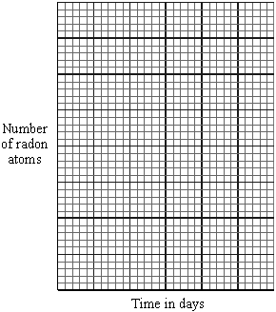
(3)

(ii) After 20 days, how many of the radon atoms from the original sample of air will have decayed? Show clearly how you work out your answer.
..........................................................................................................................
..........................................................................................................................
..........................................................................................................................
Number of radon atoms decayed = ..........................
(3)

(c) Fairly constant concentrations of radon gas have been found in some deep mine shafts.
(i) Suggest why the concentration of radon gas remains fairly constant although the radon gas decays.
..........................................................................................................................
..........................................................................................................................
(1)

(ii) Explain why the long term exposure to large concentrations of radon gas could be a danger to health.
..........................................................................................................................
..........................................................................................................................
..........................................................................................................................
..........................................................................................................................
(2)
(Total 11 marks)

Q5. The diagram shows a helium atom.

(a) (i) Use the words in the box to label the diagram.

electron neutron proton

(2)

(ii) An alpha particle is the same as the nucleus of a helium atom.
How is an alpha particle different from a helium atom?
...........................................................................................................................
...........................................................................................................................
(1)

(b) The graph shows how the count rate from a sample of radioactive sodium-24 changes with time.
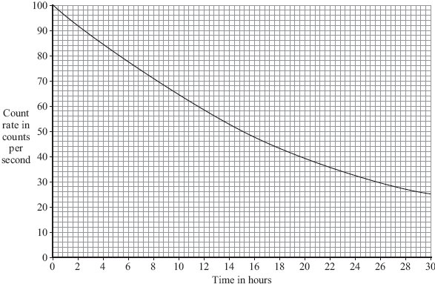

(i) How many hours does it take for the count rate to fall from 100 counts per second to 50 counts per second?
Time = .............................. hours
(1)

(ii) What is the half-life of sodium-24?
Half-life = .............................. hours
(1)

(c) A smoke detector contains a small amount of americium-241.
Americium-241 is a radioactive substance which emits alpha particles. It has a half-life of 432 years.
(i) Which one of the following statements gives a reason why the americium-241 inside the smoke detector will not need replacing?
Put a tick () in the box next to your answer.
The alpha particles have a low energy.
People replace smoke detectors every few years.
Americium-241 has a long half-life.
(1)

(ii) The diagram shows the label on the back of the smoke detector.
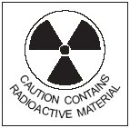
Why do people need to know that the smoke detector contains a radioactive material?
...........................................................................................................................
...........................................................................................................................
(1)
(Total 7 marks)

Q6. (a) Complete the following table for an atom of uranium-238 (U)

mass number | 238
number of protons | 92
number of neutrons

(1)

(b) Complete the following sentence.
The name given to the number of protons in an atom is the proton number or the
............................................................ .
(1)

(c) An atom of uranium-238 (U) decays to form an atom of thorium-234 (Th).
(i) What type of radiation, alpha, beta or gamma, is emitted by uranium-238?
...........................................................................................................................
(1)
(ii) Why does an atom that decays by emitting alpha or beta radiation become an atom of a different element?
...........................................................................................................................
...........................................................................................................................
(1)
(Total 4 marks)

Q7. In 1986, a nuclear reactor exploded in a power station at Chernobyl in the Ukraine.
(a) The table gives information about some of the radioactive substances released into the air by the explosion.

Radioactive  substance | Half-life | Type of radiation  emitted
Iodine-131 | 8 days | beta and gamma
Caesium-134 | 2 years | beta
Caesium-137 | 30 years | beta

(i) How is the structure of a caesium-134 atom different from the structure of a caesium-137 atom?
..........................................................................................................................
(1)

(ii) What is a beta particle and from which part of an atom is a beta particle emitted?
..........................................................................................................................
..........................................................................................................................
(1)

(iii) Once a radioactive substance is dissolved in rainwater, it can enter the food chain.
Following the Chernobyl explosion, some milk supplies were found to be radioactive.
If one litre of milk contaminated with iodine-131 gives a count rate of 400 counts/second, how long will it take for the count rate to fall to 25 counts/second?
Show clearly how you work out your answer.
..........................................................................................................................
..........................................................................................................................
..........................................................................................................................
Time taken = ................................................. days
(2)

(iv) After 20 years, the caesium-137 emitted into the atmosphere is a more serious problem than the iodine-131.
Explain why.
..........................................................................................................................
..........................................................................................................................
..........................................................................................................................
..........................................................................................................................
..........................................................................................................................
(2)

(b) The bar chart compares the incidence of thyroid cancer in Ukrainian children, aged 0–14 years, before and after the Chernobyl explosion.
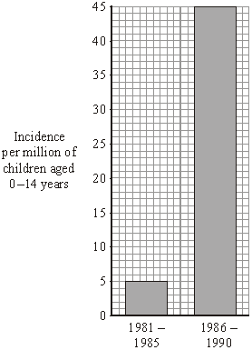
Of the children that developed thyroid cancer, 64% lived in the areas most contaminated by the radiation.

Considering this data, can you be certain that a child who developed thyroid cancer between 1986 and 1990 did so because of the Chernobyl explosion?
Explain the reason for your answer.
....................................................................................................................................
....................................................................................................................................
....................................................................................................................................
....................................................................................................................................
(2)

(c) In 1991, some scientists compared the health of two groups of people: a control group and a group that had been exposed to the radiation from Chernobyl.
What people would have been in the control group?
....................................................................................................................................
(1)

(d) Although there are some risks associated with nuclear power stations, it is likely that new ones will be built.
Give two reasons to justify the use of nuclear power.
1 .................................................................................................................................
....................................................................................................................................
2 .................................................................................................................................
....................................................................................................................................
(2)
(Total 11 marks)

