Q1. A student did an experiment with two strips of polythene. She held the strips together at one end. She rubbed down one strip with a dry cloth. Then she rubbed down the other strip with the dry cloth. Still holding the top ends together, she held up the strips.
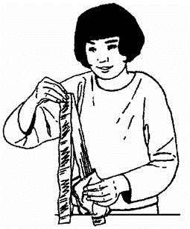

(a) (i) What movement would you expect to see?
...........................................................................................................................
...........................................................................................................................
(1)

(ii) Why do the strips move in this way?
...........................................................................................................................
(2)

(b) Complete the four spaces in the passage.
Each strip has a negative charge. The cloth is left with a............................................
charge. This is because particles called .................................. have been transferred
from the .................................... to the ........................................ .
(4)

(c) The student tried the experiment using two strips of aluminium. The strips did not move.
Complete each of the sentences.
(i) Materials, such as aluminium, which electricity will pass through easily, are
called ........................................ .
(1)

(ii) Materials, such as polythene which electricity will not pass through easily, are
called ......................................... .
(1)
(Total 9 marks)

Q2. A pupil did an experiment following the instructions below.
1. Take a polythene rod (AB), hold it at its centre and rub both ends with a cloth.
2. Suspend the rod, without touching the ends, from a stand using a stirrup and nylon thread.
3. Take a perspex rod (CD) and rub it with another cloth.
4. Without touching the ends of the perspex rod bring each end of the perspex rod up to, but without touching, each end of the polythene rod.
5. Make notes on what is observed.

The diagram below shows how the apparatus is to be set up.
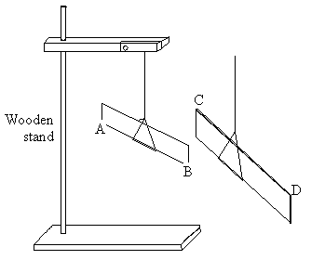

(a) When end C was brought near to end B they attracted each other.
(i) Explain why they attracted each other.
.........................................................................................................................
.........................................................................................................................

(ii) What would happen if end C were brought near end A?
.........................................................................................................................
(3)

(b) The experiment was repeated with two polythene rods.
(i) Describe what you would expect the pupil to observe as the end of one rod was brought near to the end of the other.
.........................................................................................................................
.........................................................................................................................

(ii) Explain your answer.
.........................................................................................................................
.........................................................................................................................
(2)

(c) Explain, in terms of electron movement, what happened as the rods were rubbed with the cloths.
...................................................................................................................................
...................................................................................................................................
...................................................................................................................................
...................................................................................................................................
...................................................................................................................................
(3)
(Total 8 marks)

Q3. During car journeys, the driver will often become electrostatically charged.
This is more noticeable on dry days than on damp, humid days.
(a) Explain what happens to cause the driver to become charged.
.....................................................................................................................................
.....................................................................................................................................
.....................................................................................................................................
.....................................................................................................................................
(2)

(b) Scientists were asked to find out whether the build-up of charge on the driver depends on the type of material used to make the driver’s clothes. The results of the investigation are given in the table.

Material | Humidity | Temperature in °C | Charge on the driver  in millicoulombs
Nylon | 48% | 18 | 3.0 to 3.2
Wool | 48% | 18 | 2.4 to 2.5
Cotton | 48% | 18 | 1.4 to 1.7

Humidity is a measure of how much water vapour the air can hold.

(i) Why was it important that the scientists controlled the humidity?
...........................................................................................................................
...........................................................................................................................
(1)

(ii) Does the data in the table show that the charge on the driver would always be less if they were to wear cotton clothing?
Give a reason for your answer.
...........................................................................................................................
...........................................................................................................................
(1)
(Total 4 marks)

Q4. The drawing shows an experiment using a low voltage supply, a joulemeter, a small immersion heater and a container filled with water.
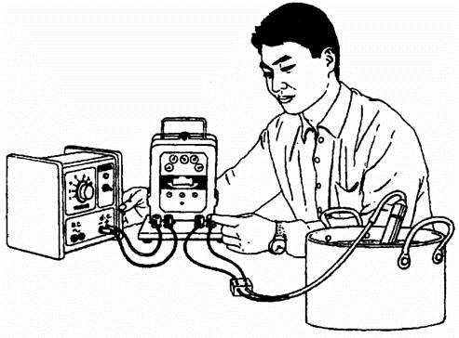
The voltage was set at 6 V d.c. The reading on the joulemeter at the start of the experiment was 78 882 and 5 minutes later it was 80 142.

(i) Use the equation:
voltage = 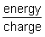
to work out the total charge which flowed through the immersion heater in five minutes. Clearly show how you get to your answer and give the unit.
.....................................................................................................................................
.....................................................................................................................................
.....................................................................................................................................
Charge = ............................................
(3)

(ii) Calculate the current through the immersion heater during the 5 minutes. Write the equation you are going to use, show clearly how you get to your answer and give the unit.
.....................................................................................................................................
.....................................................................................................................................
Current = .........................................
(3)
(Total 6 marks)

