Q1. (a) The diagrams represent three atoms X, Y and Z.
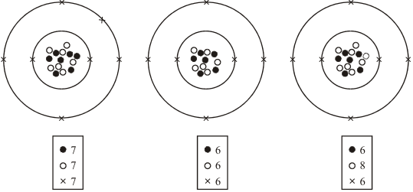
X Y Z
Which two of the atoms are from the same element?
.....................................................................................................................................
Give a reason for your answer.
.....................................................................................................................................
.....................................................................................................................................
(2)

(b) In the early part of the 20th century some scientists investigated the paths taken by positively charged alpha particles into and out of a very thin piece of gold foil. The diagram shows the paths of three alpha particles.
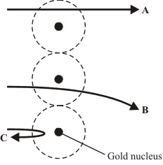

Explain the different paths A, B and C of the alpha particles.
To gain full marks in this question you should write your ideas in good English. Put them into a sensible order and use the correct scientific words.
.....................................................................................................................................
.....................................................................................................................................
.....................................................................................................................................
.....................................................................................................................................
.....................................................................................................................................
(3)
(Total 5 marks)

Q2. (a) Tritium () is an isotope of hydrogen. Tritium has a proton number of 1 and a mass number of 3.
(i) The diagram below shows a simple model of a tritium atom. Complete the diagram by adding the names of the particles indicated by the labels.
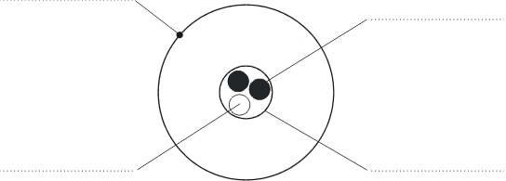
(4)

(ii) Explain how the nucleus of an ordinary hydrogen atom is different from the nucleus of a tritium atom. Ordinary hydrogen atoms () have a mass number of 1.
.........................................................................................................................
.........................................................................................................................
.........................................................................................................................
(2)

(iii) Tritium is a radioactive substance which emits beta (β) radiation.
Why do the atoms of some substances give out radiation?
.........................................................................................................................
.........................................................................................................................
(2)

(b) Tritium is one of the elements found in the waste material of the nuclear power industry. The diagram below shows a worker behind a protective screen. The container holds a mixture of different waste materials which emit alpha (α), beta (β) and gamma (γ) radiation.
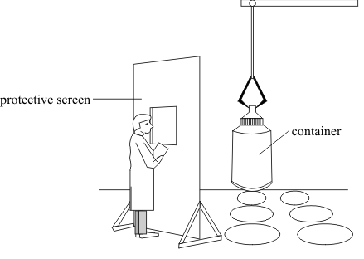

Suggest a suitable material for the protective screen. The material should prevent radiation from the container reaching the worker. Explain your answer.
...................................................................................................................................
...................................................................................................................................
...................................................................................................................................
(2)
(Total 10 marks)

##
(a) Atoms are made up of three types of particle called protons, neutrons and electrons.
Complete the table below to show the relative mass and charge of a neutron and an electron. The relative mass and charge of a proton has already been done for you.
PARTICLE | RELATIVE MASS | RELATIVE CHARGE
proton | 1 | +1
neutron
electron

(2)

(b) The diagram below shows the paths of two alpha particles A and B, into and out of a thin piece of metal foil.
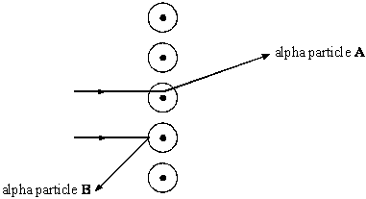
The paths of the alpha particles depend on the forces on them in the metal.
Describe the model of the atom which is used to explain the paths of alpha particles aimed at thin sheets of metal foil.
....................................................................................................................................
....................................................................................................................................
....................................................................................................................................
(3)
(Total 5 marks)

Q4. The diagram below shows the paths of two alpha particles A and B into and out of a thin piece of metal foil.
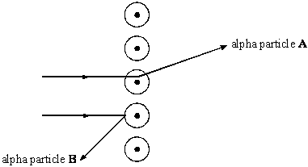

(a) The paths of the alpha particles depend on the forces on them in the metal.
Describe the model of the atom which is used to explain the paths of alpha particles aimed at thin sheets of metal foil.
....................................................................................................................................
....................................................................................................................................
....................................................................................................................................
....................................................................................................................................
(3)

(b) Scientists used to believe that atoms were made up of negative charges embedded in a positive ‘dough’. This is called the ‘plum pudding’ model of the atom.
The diagram below shows a model of such an atom.
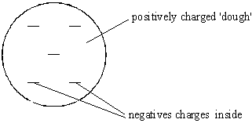

(i) Explain how the ‘plum pudding’ model of the atom can explain why alpha particle A is deflected through a very small angle.
............................................................................................................................
............................................................................................................................
............................................................................................................................
............................................................................................................................
............................................................................................................................
(2)

(ii) Explain why the ‘plum pudding’ model of the atom can not explain the large deflection of alpha particle B.
............................................................................................................................
............................................................................................................................
............................................................................................................................
............................................................................................................................
............................................................................................................................
............................................................................................................................
(3)

(c) We now believe that atoms are made up of three types of particles called protons, neutrons and electrons.
Complete the table below to show the relative mass and charge of a neutron and an electron. The relative mass and charge of a proton have already been done for you.
PARTICLE | RELATIVE MASS | RELATIVE CHARGE
proton | 1 | +1
neutron
electron

(2)

(d) The diagrams below show the nuclei of four different atoms A, B, C and D.
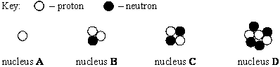

(i) State the mass number of C. ..................................................

(ii) Which two are isotopes of the same element? .................... and .....................
Explain your answer.
............................................................................................................................
............................................................................................................................
............................................................................................................................
............................................................................................................................
(4)
(Total 14 marks)

Q5. The diagrams below represent three atoms, A, B and C.
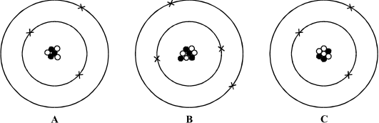

(a) Two of the atoms are from the same element.
(i) Which of A, B and C is an atom of a different element? .................................
(ii) Give one reason for your answer.
...........................................................................................................................
...........................................................................................................................
...........................................................................................................................
(2)

(b) Two of these atoms are isotopes of the same element.
(i) Which two are isotopes of the same element? .................. and ........................
(ii) Explain your answer.
...........................................................................................................................
...........................................................................................................................
...........................................................................................................................
(3)
(Total 5 marks)

